- Designed Pseudocode/Algorithm can be explained.
START
User Login
If FILEUPLOAD
Save the encrypted file in cloud server
Generate Log and save in blockchain
Else if FILEEDIT
Access the file from cloudserver
Edit content and save in cloud
Generate log and save in blockchain
Else if FILEDELETE
Delete the file from cloud
Save log in blockchain
Else if FILESHARE
Share the file to other user
Save log in blockchain
Else if VIEWLOG
Get log details from blockchain and show to user
END

- Master class diagram

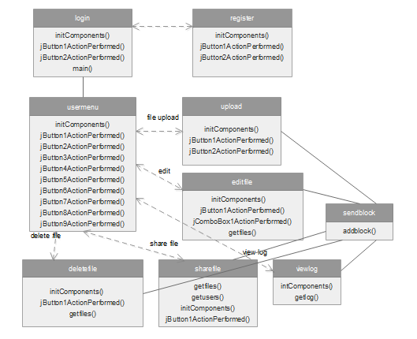

- ER Diagram

